Improving the Performance of Long-Term Stock Investments with a Two-Stage LLM Filtering Framework

Abstract
Driven by the rapid progress of Large Language Models (LLMs) such as ChatGPT, Gemini, and Claude, researchers are increasingly exploring AI-driven investment strategies. Previous research into LLM-driven investing often relies on simultaneous ingestion of multiple information sources, an approach that can introduce noise and dilute relevant signals. To address this limitation, we developed a two-stage sequential filtering framework in which news articles are first analyzed to identify candidate stocks and financial reports are subsequently used to validate and refine those selections. Using 2,759 portfolio runs across multiple models, temperatures, filtering configurations, and evaluation windows, we find that filtering that eliminates only a moderate number of companies between stages consistently outperforms both the unfiltered single-pass methodology and the S&P 500 benchmark. For the strongest model, GPT-5.1, the best configuration — twenty candidate stocks narrowed to a ten-stock portfolio — achieved the highest mean ROI (60.6%) and beat the unfiltered baseline in 81.5% of matched evaluation windows; other moderately filtered configurations beat that baseline in roughly three of every four windows. Across all configurations GPT-5.1 outperformed the S&P 500 in 96.5% of runs. Because the unfiltered baseline also beat the S&P 500, this market advantage reflects model and sector strength; the filtering's specific contribution is its gain over that baseline — up to 15 percentage points of additional mean ROI. These findings suggest that structural organization of information is a critical component of LLM-based investment systems and can significantly improve long-term investment performance.
Keywords: large language models, investment strategy, two-stage filtering, portfolio construction, financial news analysis, GPT-5.1

Introduction

Background and Context
Robust financial analysis requires integrating qualitative sentiment—extracted from earnings reports and news sources—with quantitative metrics such as historical price, volume, and risk profiles¹. Capitalizing on their natural language understanding capabilities, LLMs are increasingly applied to financial markets to generate directional signals—buy, hold, or sell recommendations—by synthesizing information from news, earnings reports, and regulatory filings^{2,3,4}.
The bulk of existing LLM-based investment research focuses on short-term trading horizons—high-frequency trading or single-day price prediction^{2,3,4}. A growing subset of work has begun exploring longer horizons^{5,6}, but this literature remains limited in scope: most studies do not guard against lookahead bias by restricting the model to information available at the simulated investment date, and few target holding periods exceeding one quarter. Long-term investing, by contrast, demands sustained reasoning over extended horizons—a domain traditionally reserved for human analysts who synthesize broad macroeconomic insights, qualitative judgment, and multi-year strategic perspectives⁵. This gap motivates the present work: we investigate whether a structured LLM pipeline can generate reliable investment strategies over 12-month holding periods under conditions a real investor could reproduce, using only information available at the time of each decision and avoiding any look-ahead into future data.
Large language models have emerged as transformative tools in finance. Their capacity for summarization⁹, information extraction, and natural language generation suits applications such as market trend monitoring, risk factor identification, and investment decision support¹. As LLMs have scaled, their ability to process complex, heterogeneous financial datasets has grown substantially², but this capability brings interpretability challenges: model opacity makes it difficult to audit whether outputs reflect genuine financial reasoning or spurious correlations from pre-training⁵. Because undetected biases can propagate into consequential financial decisions⁷, realizing the potential of LLMs in financial analysis depends on clear, principled deployment frameworks⁸.

Large Language Models in Financial Forecasting
Existing research work has demonstrated the proficiency of LLMs in synthesizing heterogeneous financial data to extract predictive market signals^{10,11,12}. Studies integrating LLMs with conventional forecasting techniques reported improved predictive accuracy, attributed to the models’ ability to capture nuanced relationships between news sentiment and price movements^{13,14,15}. A complementary line of work combines document embeddings with LLM-generated representations to construct richer proxies for investor sentiment and macroeconomic conditions^{10,11}. By automating the extraction of financially relevant signals from unstructured text, LLMs reduce the manual overhead of information processing and enable more scalable financial modeling pipelines^{12,13}. Researchers have further combined LLMs with established quantitative frameworks—for example, integrating LLM-generated sentiment scores with LSTM networks and Black-Litterman portfolio optimization models—and report performance improvements over conventional approaches alone.

Multi-Agent LLM Systems for Trading
Beyond single-model deployments, LLMs are increasingly employed as components of multi-agent trading systems, in which specialized agents interact to simulate market dynamics and refine portfolio strategies^{16,17,18,19}. Such systems incorporate layered memory architectures and role-differentiated agent designs, enabling individual agents to retain relevant historical context and adapt their behavior as market conditions evolve^{20,21}. Empirical evidence indicates that multi-agent configurations frequently outperform single-agent baselines, as the diversity of strategies across agents reduces overfitting observed in isolated backtests^{22,23}. Within these architectures, individual agents are assigned distinct functions—portfolio allocation, risk assessment, and real-time monitoring—enabling a modular division of responsibilities that exploits the natural language flexibility of LLMs^{16,24}. Representative frameworks such as 3S-Trader²⁵, AlphaAgents²⁶, FinRobot²⁷, and tool-augmented multimodal foundation agents²⁸ coordinate multiple LLMs to score candidate stocks, construct a portfolio, and iteratively refine strategies from historical performance weekly, though at the cost of considerable system complexity.

Sentiment Analysis and Market Dynamics
LLMs have proven adept at inferring investor sentiment and forecasting market movements by analyzing news articles and social media data^{6,29,30}. By leveraging pre-training on large-scale financial datasets, LLMs can discern specialized terminology and complex rhetorical structures, providing an effective framework for mapping textual information to market price movements^{3,31}. Sentiment-augmented models have been shown to identify early indicators of trend reversals, offering potential informational advantages for trading decisions. By processing vast quantities of unstructured data at scale, LLMs enable the development of more agile, information-rich trading strategies that respond to market shifts in real time^{32,33,34}. This body of research extends foundational work by demonstrating that media-derived content yields quantifiable sentiment signals that have a direct and measurable impact on equity prices⁷.

Reinforcement Learning and Financial LLMs
Integrating LLMs with reinforcement learning (RL) has produced further gains in automated trading^{35,36,37}. RL-augmented systems refine strategy continuously through feedback from simulated or live markets^{38,39}, and framing portfolio management as a sequential decision problem provides a principled balance between exploring new strategies and exploiting established ones, improving risk-adjusted returns^{40,41}. This adaptability suits non-stationary market regimes^{4,42,43}.

Benchmarks, Evaluation, and Bias
Systematic benchmarking provides a principled basis for evaluating financial LLMs^{16,18,44}. Standardized datasets enable rigorous comparison across models and multi-agent systems on textual comprehension, sentiment extraction, and portfolio optimization^{20,21,24}. A consistent finding is that accuracy alone is insufficient — models must perform reliably under live-market pressures^{6,23,29} — so continued benchmark development is essential to ensure reported advances are genuine rather than artifacts of favorable evaluation conditions^{3,30,31}.
A critical concern in this literature is evaluation bias. A 2025 study by Li et al. created a rigorous testing framework called FINSABER to address three common problems: survivorship bias (testing only on currently successful stocks), look-ahead bias (accidentally using future information in past decisions), and data-snooping bias (testing a strategy repeatedly on the same data until favorable results arise by chance). When they re-tested popular LLM strategies over 20 years across a wider range of stocks, the strategies' apparent advantages either disappeared or appeared much weaker. The study also found that LLM strategies often performed poorly in different market conditions — too cautious during bull markets and overly aggressive during bear markets. This highlights the need for long-term, rigorous testing and strategies that can adapt to changing market conditions.
Collectively, these studies show LLMs can generate competitive investment strategies, but they focus on improving model capability — larger architectures, multi-agent systems, reinforcement learning, or sentiment extraction. Little attention has gone to the structural architecture of information delivery: most approaches ingest heterogeneous sources simultaneously, leaving open whether alternative information frameworks might improve performance. This gap motivates our central question: can restructuring the information flow presented to an LLM systematically improve long-term investment decision-making?

Problem Statement and Rationale
Several limitations constrain LLMs in investment contexts. A primary concern is their documented inability to perform reliable numerical computation⁷: LLMs exhibit systematic arithmetic errors, limiting quantitative tasks that require precision and preventing them from replacing analysts whose judgments rest on rigorous financial modeling.
A second challenge is hallucination: LLMs can fabricate or misrepresent information with high apparent confidence⁸. In an investment context, this can result in recommendations based on non-existent corporate events, incorrect financial figures, or wholly invented analyst reports. Critically, hallucinations are not always overt. Subtle hallucinations—small distortions in attributed facts, misremembered statistics, or plausible-sounding but inaccurate characterizations of company performance—may pass undetected and propagate systematically through the recommendation pipeline, making them particularly dangerous for investment applications where errors in reasoning compound over a holding period.
A third challenge is implicit bias introduced through LLM pre-training. Because modern LLMs are trained on large corpora with a fixed knowledge cutoff, they may encode implicit awareness of future events relative to any historical analysis date, effectively providing look-ahead information that no real investor could possess at the time of decision-making. This form of data leakage is particularly problematic for backtesting: strategies that appear profitable in retrospective evaluation may be artifacts of the model’s latent knowledge of subsequent market developments rather than genuine analytical insight, casting doubt on the validity of reported results.
This study addresses two gaps tied to the challenges outlined above. First, long-term LLM investment strategies remain underexplored relative to short-term counterparts, leaving open whether LLMs can sustain reliable performance over multi-month horizons. Second, existing approaches typically ingest heterogeneous information sources simultaneously, risking signal dilution, information overload, and inconsistent decision-making.

Significance and Purpose
This paper proposes a two-stage structured pipeline for generating reliable long-term investment strategies with large language models. The framework decomposes the investment task into two sequential stages: a news-based candidate selection stage, in which the LLM identifies a set of candidate stocks from a curated set of financial news articles; and a financial report validation stage, in which the LLM reads company financial reports for each candidate and produces a smaller, higher-conviction final portfolio. This sequential evaluation of information sources—rather than simultaneous ingestion—constitutes the central methodological contribution of this work.
The framework addresses all three challenges. Decomposing the task constrains each stage to a well-defined subtask, reducing hallucination and improving consistency; strict temporal boundaries prevent look-ahead leakage; and all numerical computation is delegated to deterministic external modules, avoiding reliance on LLM arithmetic.

Objectives
This paper delivers three primary contributions:
- A novel two-stage news-and-financial-report architecture for LLM-driven long-term investment strategy generation, featuring a principled separation of qualitative and quantitative reasoning that measurably improves deployment consistency.
- Extensive empirical validation centered on advanced frontier models, demonstrating that moderate filtering configurations — those that keep a mid-sized candidate pool and roughly halve it between stages — achieve a mean ROI of up to 60.6%, outperform the unfiltered baseline in 74–82% of matched evaluation windows — the range spans the four well-sized configurations — and beat the S&P 500 benchmark in 96.5% of runs.
- A systematic sensitivity analysis of returns and consistency across ten distinct pipeline configurations. This analysis establishes that while moderate filtering consistently improves upon single-pass methodologies, aggressive over-filtering — forcing the model to draw from an oversized candidate pool it cannot fill with strong companies — degrades performance. Furthermore, we demonstrate that the optimal filtering threshold is model-dependent and that, for any target portfolio size, the ideal configuration requires a Stage One candidate pool roughly twice that size.

Scope and Limitations
This study is scoped to long-only, buy-and-hold portfolios drawn from large-capitalization technology and semiconductor equities, evaluated over rolling 12-month horizons using three model variants (GPT-4o, GPT-4o-mini, and GPT-5.1). Returns are computed before transaction costs and taxes, and all evaluation windows respect each model's training cutoff. Broader limitations are addressed in the Discussion.

Methodology Overview
We propose a two-stage sequential filtering framework in which news articles and financial reports are evaluated separately. In Stage One the model analyzes historical news to identify candidate opportunities; in Stage Two financial reports are used to validate and refine those candidates into a final portfolio. This decomposition constrains the model to a well-defined reasoning task at each stage, letting us directly evaluate the impact of structural organization of information on investment performance.
The evaluation enforces strict temporal constraints throughout to eliminate the look-ahead and data-snooping biases identified by Li et al. (2025) and others. All input data are sourced from dates strictly preceding each evaluation window, and model-specific training-cutoff restrictions further reduce lookahead risk, ensuring reported performance reflects genuine analytical capability rather than latent knowledge from pre-training.

Methods
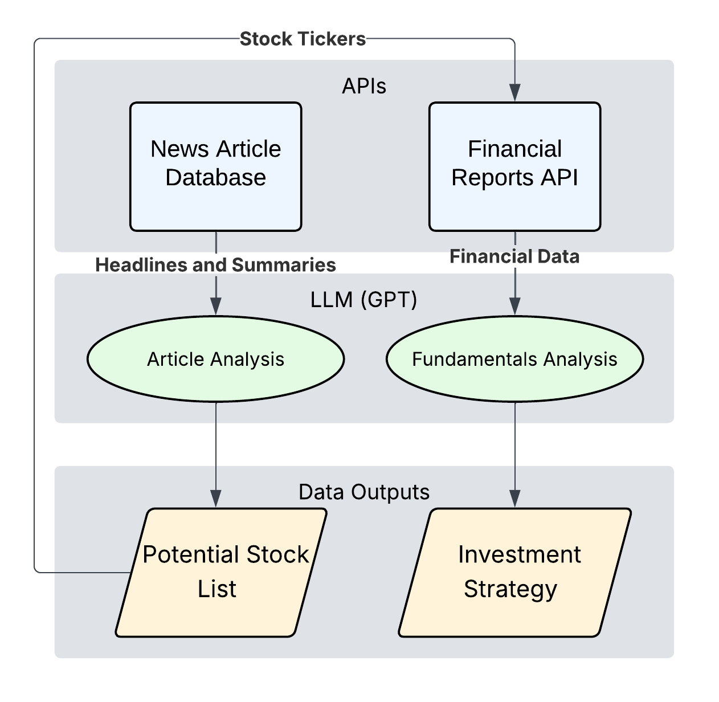

Figure 1: A Two-Stage Filtering Framework for LLM-Driven Investing

Overall Framework Overview
The framework's architecture is illustrated in Figure 1. Its central design principle is that different information sources should be evaluated sequentially rather than simultaneously: existing approaches typically provide news, financial reports, and other market information in a single reasoning step, which maximizes information availability but can dilute relevant signals. The framework instead separates opportunity discovery from financial validation.
The framework consists of four primary phases. First, historical news articles are collected from a fixed pre-analysis window. Second, these articles are used to prompt an LLM to generate a set of candidate stocks with qualitative justifications, constituting Stage One of the framework. Third, financial reports are retrieved for each candidate stock and provided to the LLM in a second analysis stage. The model then evaluates these reports and produces a smaller set of final recommendations. The notation X→Y used throughout this paper denotes this structure: X represents the number of candidate stocks identified during Stage One, while Y represents the number of final investment selections produced after financial-report validation in Stage Two. Finally, the resulting stock selections and allocation weights are used to construct and evaluate a long-only investment portfolio over a predefined investment horizon.
One exception to this general structure is the Ranked configuration. In the other configurations, the LLM is asked to return a fixed number of candidates at each stage. In Ranked, the LLM instead ranks all candidate opportunities without limiting how many it returns; the number is capped to a set value only at the final investment step.
By separating qualitative reasoning—interpreting news narratives and financial-report language—from quantitative evaluation—deterministic calculation of returns, volatility, and benchmark comparisons by external code—the framework assigns each component to the tool best suited to it, improving reliability and interpretability and allowing performance differences to be attributed to specific stages.
To evaluate the effect of structural organization of information, multiple filtering configurations were tested, including unfiltered baseline, Ranked, 30→15, 30→10, 30→5, 20→10, 20→5, 10→5, 10→3, and 5→3. Here the unfiltered baseline represents the conventional approach used in much of the existing literature, in which news articles and financial reports are analyzed simultaneously without sequential filtering.

Data Sources
Three primary categories of data are used in this study: news articles, financial reports, and historical market prices. News data is sourced exclusively from a reputable financial news provider using an application programming interface. All articles are retrieved from dates strictly before the beginning of each evaluation period to prevent future information leakage.
Financial reports are retrieved for each stock that passes Stage One, providing structured company-level data the LLM uses in Stage Two to validate and refine the candidate list. Like news, reports are sourced only from dates preceding the evaluation period. (In the unfiltered baseline, financial reports for the full union of stocks selected by any configuration are provided alongside all available news articles.)
Market data comprises daily adjusted closing prices for individual stocks and benchmark indices, introduced only after recommendations are finalized. This isolates the reasoning process from look-ahead bias, and all return calculations and risk metrics are computed externally using deterministic formulas.

News Article Relevance Screening Process
Raw news often contains material irrelevant to investment decisions—opinion pieces, general technology discussion, or political commentary without market implications. A dedicated LLM-based relevance screening step therefore precedes strategy generation: the LLM labels each article financially relevant or irrelevant under a constrained classification prompt, with no manual review or rule-based expressions, keeping screening consistent and scalable across evaluation windows.
Batches of articles are screened with a constrained prompt selecting only those with clear, direct market relevance—earnings announcements, major corporate events, regulatory changes, macroeconomic indicators, and industry-level shifts; articles without clear investment impact are excluded.
Screened articles are stored in a curated database and reused downstream, letting a small, high-quality input set drive strategy generation and reducing the influence of irrelevant or misleading information.

LLM-Based Strategy Generation
The screened news dataset then prompts the LLM to generate investment recommendations, identifying companies likely to benefit from the trends and events described. For each selected stock the model must provide a concise justification of its reasoning.
The model also assigns each recommendation a percentage allocation, with allocations summing to 100 percent.
The output is a structured strategy of tickers, allocation weights, and qualitative explanations, enabling transparent evaluation without further LLM inference.
In the two-stage configurations this constitutes Stage One. Following the X→Y notation defined in the framework overview, financial reports are fetched for each of the X candidates and provided alongside the Stage One justifications; the model evaluates each candidate against its report data and produces a final, smaller set of Y recommendations with updated justifications and weights.

Bias and Hallucination Mitigation
Large language models are known to exhibit hallucinations and implicit bias⁴⁵, particularly when prompted with open-ended tasks or incomplete constraints. To mitigate these issues, several safeguards are integrated into the proposed framework.
First, strict temporal constraints are enforced at every stage of the pipeline. All news articles and financial reports provided to the LLM originate from dates strictly preceding the evaluation period, and no market price data is included in any prompt. This design eliminates look-ahead bias because the LLM cannot receive—directly or indirectly—any information about price movements that occurred after the analysis date. Without this constraint, even a subtle mention of a post-analysis event in a news article could allow the model to exploit latent knowledge from pre-training, making retrospective returns appear higher than any real investor could achieve.
Second, the LLM must justify each recommendation explicitly. Justifications serve as an internal consistency check: recommendations lacking a clear connection to the input information can be identified and excluded.
Finally, the framework bars the LLM from numerical computation or return estimation, delegating all mathematics to external deterministic modules, so known weaknesses in mathematical reasoning and hallucinations cannot directly affect performance metrics.

Portfolio Construction
The investment strategies generated by the LLM are translated into portfolios using a standardized construction process, with each recommended stock weighted by its model-assigned allocation.
All portfolios are long-only, buy-and-hold: no leverage, short selling, or derivatives, with positions established at the start of the evaluation period and held without rebalancing, aligning the strategy with realistic long-term investment behavior.
Portfolio values are computed using adjusted closing prices to account for stock splits and dividends. The initial portfolio value is normalized, and returns are calculated based solely on price appreciation over the selected time horizon.

Permutation Analysis Framework
To evaluate robustness, a large-scale permutation analysis was conducted across models, temperatures, filtering configurations, and evaluation windows.
Three language models were evaluated: GPT-4o, GPT-4o-mini, and GPT-5.1. For each model, experiments were conducted at temperatures of 0.3, 0.4, and 0.5, across the ten filtering configurations defined in the framework overview.
In the X→Y notation used throughout, X is the number of candidate stocks the model proposes in Stage One and Y is the number retained in the final portfolio after Stage-Two validation; the unfiltered baseline selects the portfolio in a single pass, and the Ranked configuration ranks the candidates without imposing a fixed Stage-One cap. We use moderate filtering to mean a configuration built on a mid-sized initial pool — ten or twenty candidates — narrowed to a focused portfolio (for example 20→10, 10→5, 10→3, or 20→5), and aggressive (or over-) filtering to mean a configuration built on an oversized thirty-candidate pool that is then cut steeply, such as 30→5, a six-fold reduction. These labels describe the structural settings only and make no assumption about performance.
Evaluation windows use rolling 12-month horizons with multiple start dates, exposing the framework to different market environments and reducing the chance that results reflect a single favorable period. Each valid combination of model, temperature, configuration, and window was executed independently.
Model-specific training-cutoff restrictions were enforced to reduce the risk of lookahead bias influencing our recommendations. Only evaluation windows that satisfied these temporal requirements were included in the final analysis.
The final dataset comprised 2,759 matched portfolio runs. Because the matched-permutation design controls for model capability, temperature, and evaluation window, performance differences can be attributed to the filtering framework itself rather than to market conditions or model selection.

Evaluation Methodology
Strategy performance is evaluated using return-based, benchmark-relative, and comparative metrics. The primary performance measure is return on investment (ROI), calculated over fixed 12-month evaluation windows. Portfolio performance is compared against the S&P 500 index over the same period, allowing the calculation of benchmark-relative excess return (alpha).
Baseline win rates are also computed between each filtering configuration and the unfiltered baseline generated with the same model, temperature, and window — the percentage of windows in which the configuration achieves higher ROI — directly assessing whether sequential filtering improves portfolio quality.
Portfolio variability is evaluated using standard deviation and coefficient of variation (CV), the latter a scale-independent measure of variability relative to average return, permitting simultaneous evaluation of performance and stability.
Finally, results were aggregated across all models, temperatures, configurations, and evaluation windows to discern broader performance trends and assess the interplay between model capability and the structural organization of information.

Statistical Limitations
Multiple configurations share overlapping evaluation windows, source articles, and partially overlapping candidate portfolios. Consequently, observations are not fully independent. Statistical comparisons should therefore be interpreted as indicators of effect magnitude and practical significance rather than fully independent experimental samples. Reported confidence intervals and p-values are approximate and should be treated as heuristic rather than exact.

Statistical Testing Strategy
For configuration-level analysis, ROI distributions are grouped according to filtering structure and compared using one-way analysis of variance (ANOVA). When significant differences are detected, post-hoc pairwise comparisons are performed to identify which specific configurations diverge most strongly. Particular attention is paid to contrasting moderate filtering regimes against both aggressive filtering configurations and the unfiltered baseline. Model-level analysis is conducted by grouping results according to the language model used for portfolio generation. Comparisons between GPT-4o, GPT-4o-mini, and GPT-5.1 are used to evaluate the relationship between model capability and investment performance.
Because baseline win rates are computed from matched model-temperature-window combinations, they isolate the effect of sequential filtering from broader market effects.

Results

Key Findings
Structure beats brute force. Structured two-stage filtering raised GPT-5.1's mean ROI to 60.6%, against 45.7% for unfiltered single-pass prompting — a 15-point gain — and beat that baseline in 81% of head-to-head 12-month windows.
There is a clear optimum. For GPT-5.1, performance follows an inverted-U in the size of the initial candidate pool: a pool of 10–20 candidates performs best, while pools of 5 or 30 underperform; the weaker models peak at smaller pools.
One simple rule captures it. Make the initial candidate pool about twice the size of the target portfolio — the 2× rule.
Information design rivals model choice. How the model's input was structured affected returns about as much as which model was used.
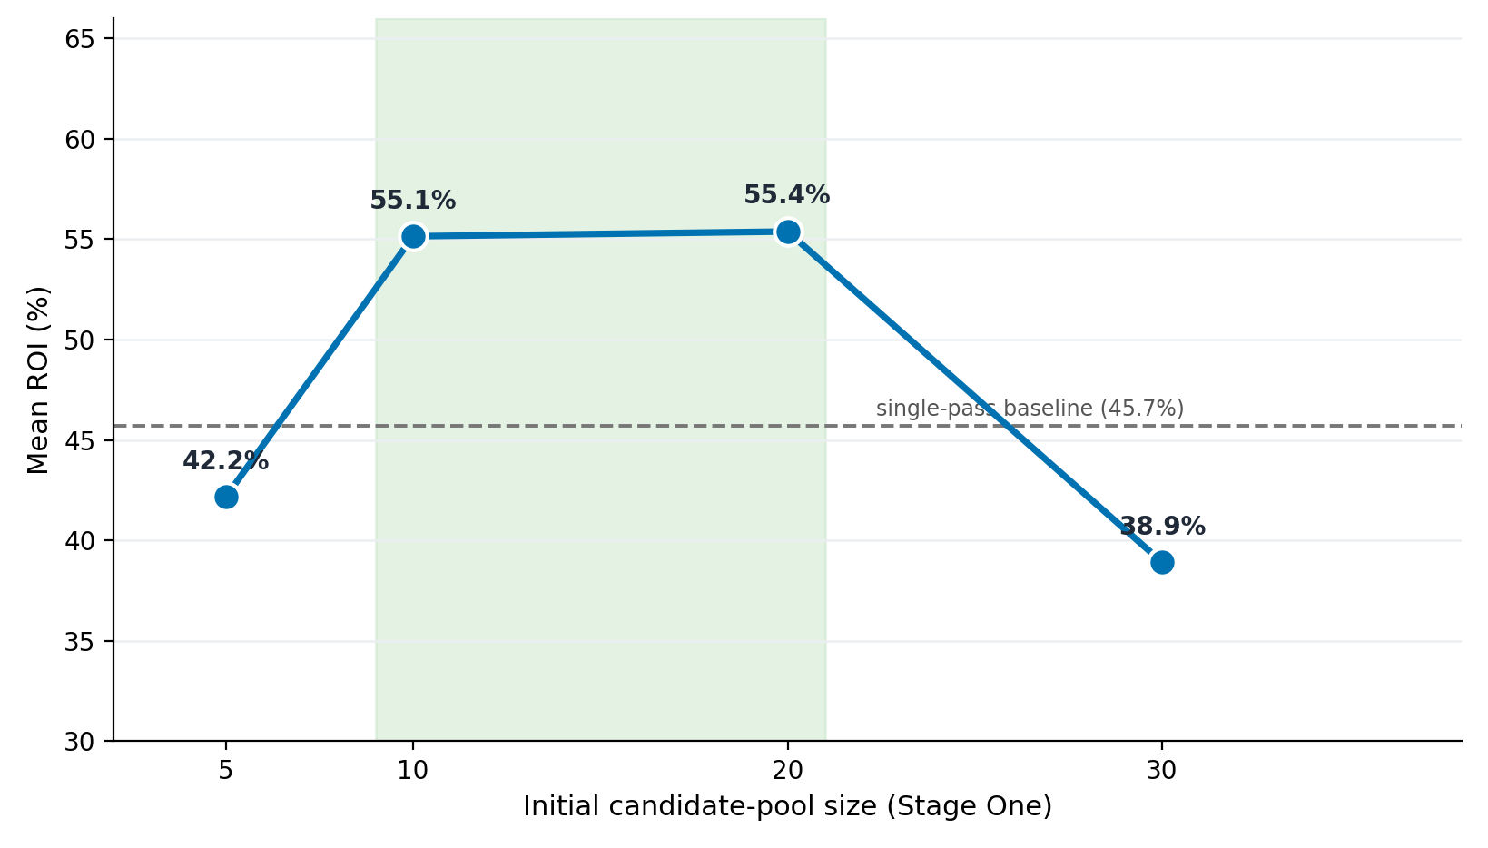

Figure 2 — The core result. GPT-5.1 mean ROI by initial candidate-pool size: performance peaks for a moderate pool (10–20) and falls below the unfiltered baseline when the model is asked for 30.

Evaluation Setup
All results derive from the 2,759 matched portfolio runs described in the Methods — three model variants (GPT-4o, GPT-4o-mini, and GPT-5.1), temperatures of 0.3, 0.4, and 0.5, and ten portfolio-generation structures — evaluated over rolling 12-month horizons spanning a range of market conditions, with each window treated as an independent experiment. Performance is reported as ROI, alpha relative to the S&P 500, standard deviation, coefficient of variation (CV), and matched-comparison win rates against the unfiltered baseline.
We state the expectation motivating the configuration sweep: an intermediate initial pool should perform best, because too few candidates limit Stage-Two choices while too many force the model to include lower-conviction names. The results test this directly.

Filtered vs. Unstructured Baseline
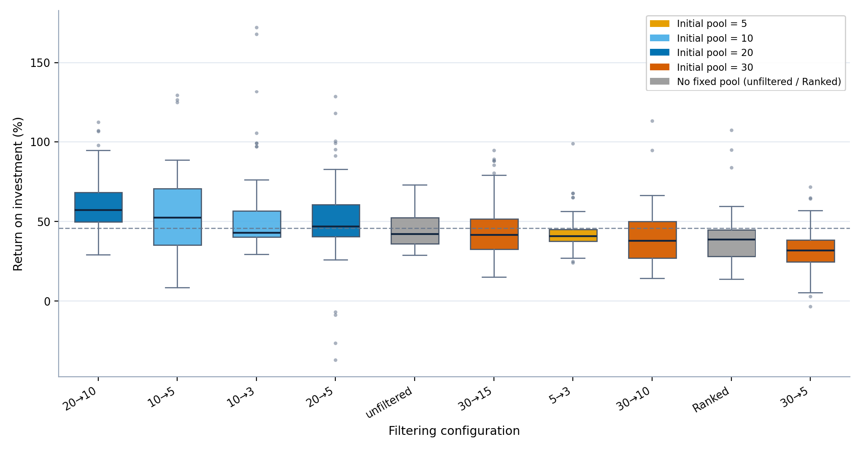

Figure 3 - Distribution of GPT-5.1 ROI for every filtering configuration, with boxes colored by initial Stage-One pool size (5, 10, 20, or 30 candidates; grey marks the unfiltered and Ranked methods, which have no fixed pool). All ten configurations are carried through the analysis; the dashed line marks the unfiltered baseline mean. Takeaway: a moderate pool of 10–20 candidates produces the highest returns, while oversized 30-candidate pools fall below the baseline.
GPT-5.1 was the strongest of the three models (see Model Comparison and Configuration Selection), so configuration-, consistency-, and temperature-level analyses are presented for GPT-5.1; the cross-model comparison appears in Figure 7. Figure 3 shows GPT-5.1's ROI distribution per configuration. Moderate filtering substantially outperformed the unfiltered baseline: 20→10 achieved the highest mean ROI (60.6%), followed by 10→5 (56.2%), 10→3 (54.1%), and 20→5 (50.4%), all well above the baseline's 45.7%.
Performance declined sharply under aggressive filtering. The four configurations that draw from an oversized thirty-candidate Stage One pool or rank candidates without a validation stage — 30→5 (32.3%), 30→10 (40.1%), 30→15 (44.2%), and Ranked (38.9%) — all underperformed even the unfiltered baseline (45.7%). All ten configurations are nonetheless retained and interpreted together in the analyses that follow, and the systematic reason for the weaker methods' lower returns is examined below.
What unites these weaker methods is a single setting rather than chance: each one either begins from the oversized thirty-candidate pool (30→15, 30→10, 30→5) or applies no validated reduction at all (Ranked). As we expected, mean ROI traces an inverted-U in the initial pool size (holding the model and evaluation windows fixed) — about 42% at five candidates, 55% at both ten and twenty, and 39% at thirty — so return falls once the starting set grows past the mid-range. The most likely cause is the size of the Stage-One request itself. Asking the model for thirty candidates forces it well past the ten to twenty companies it can identify with genuine conviction; to fill the remaining slots, it nominates marginal names it would not otherwise have proposed. These low-quality additions remain in the candidate set through the second stage and into the final portfolio, where they reduce its overall return. Because the padding originates in Stage One, no choice of final size can undo it — which is why every thirty-candidate configuration trails the baseline regardless of how aggressively it is later narrowed. A smaller pool avoids this by requesting only as many candidates as the model can justify, whereas too small a pool (five) produces the opposite problem, leaving the model too few options from which to construct a strong portfolio.
Overall, Figure 3 shows that for GPT-5.1 — the model a practitioner would deploy — structural organization of information is a major, controllable driver of performance: a moderate pool feeding a focused Stage Two maximizes return, while both under-structuring and over-filtering leave achievable return unrealized.
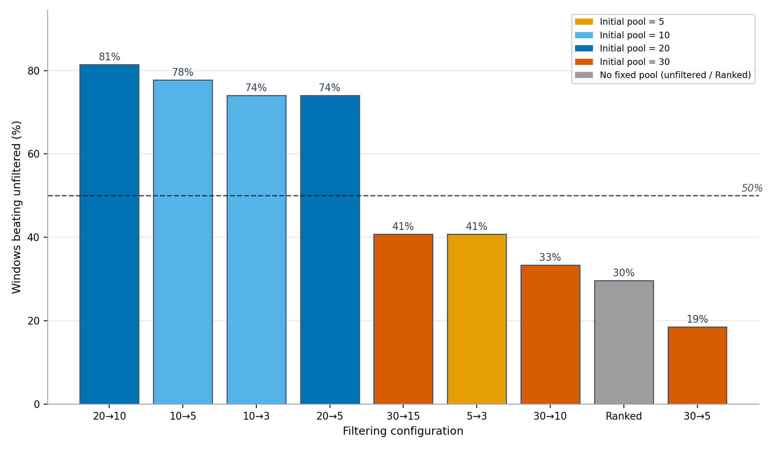

Figure 4 - Percentage of matched evaluation windows in which each GPT-5.1 filtering configuration outperformed the unfiltered baseline, with bars colored by initial Stage-One pool size. Takeaway: configurations starting from 10–20 candidates beat the baseline 74–82% of the time, while the 30-candidate configurations and Ranked all fall below 50%.
Configuration | Mean ROI (%) | Win vs Unfiltered (%)
20→10 | 60.6 | 81.5
10→5 | 56.2 | 77.8
10→3 | 54.1 | 74.1
20→5 | 50.4 | 74.1
unfiltered | 45.7 | —
30→15 | 44.2 | 40.7
5→3 | 42.2 | 40.7
30→10 | 40.1 | 33.3
Ranked | 38.9 | 29.6
30→5 | 32.3 | 18.5

Table 1 - GPT-5.1 mean ROI and win rate versus the unfiltered baseline, by filtering configuration (sorted by mean ROI). Full per-configuration statistics for all three models are reported in the supplementary information.
Matched-comparison win rates were computed for each GPT-5.1 configuration against the unfiltered baseline, holding temperature and evaluation window fixed.
Filtering substantially improved GPT-5.1's performance: 20→10 beat the unfiltered baseline in 81.5% of matched windows, followed by 10→5 (77.8%) and 10→3 and 20→5 (both 74.1%). The exception is the highly selective 5→3 (40.7%), which trades return for the lowest run-to-run variability (see Return Variance and Consistency Comparison). The well-sized configurations thus beat single-pass prompting in roughly three of four matched windows.
These win rates follow the same two settings, not the identity of any particular configuration. The methods that win most often share a mid-sized initial pool (ten or twenty candidates) narrowed by a moderate, roughly two-to-one ratio — the combination that gives the model enough candidates to rank meaningfully while keeping the final portfolio focused. 5→3 is the informative exception rather than an anomaly: starting from only five candidates, it has too small a pool to reach the top of the return range, so although its tight selection makes it the most stable configuration (see Return Variance and Consistency Comparison), it beats the baseline on return far less often. Initial pool size is therefore the dominant factor — mean return increases from small to mid-sized pools and decreases for oversized ones — and the reduction ratio acts mainly through how aggressively it narrows a given pool.
Taken together, GPT-5.1 reliably benefits from moderate filtering; because each window is a distinct 12-month holding period, the best-sized configurations outperform the unfiltered baseline in roughly three of every four years tested.

Overall Trends
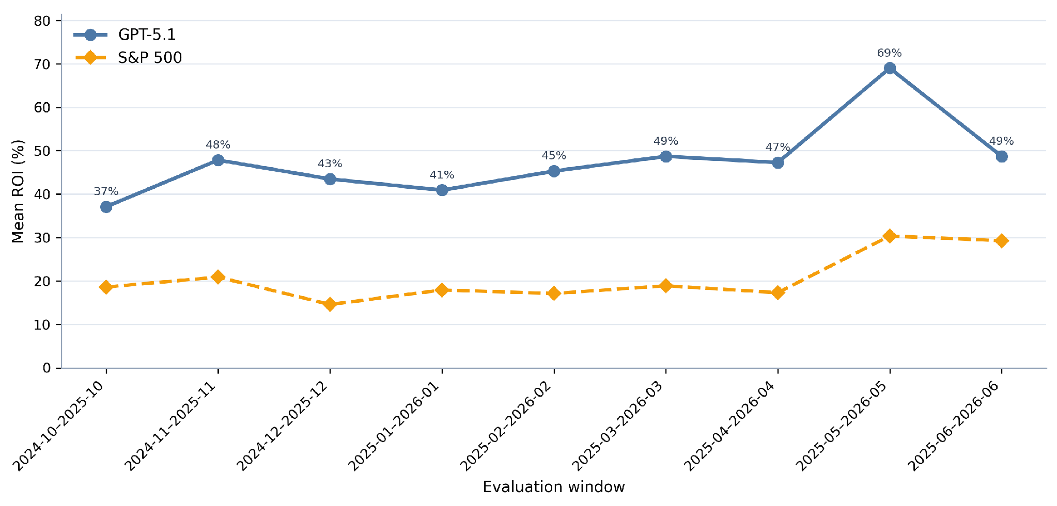

Figure 5 - GPT-5.1 mean ROI across rolling 12-month evaluation windows, with the corresponding S&P 500 benchmark return. Takeaway: GPT-5.1's mean ROI beat the market in every window (37–69% versus 15–30%).
GPT-5.1's mean ROI exceeded the S&P 500 in every evaluation window tested. Figure 5 plots its mean ROI across each rolling 12-month window against the benchmark; performance varied with the market environment but stayed above the benchmark throughout.
GPT-5.1's evaluation windows span October 2024 through June 2026; earlier windows are excluded by the model's training-cutoff constraint. The weakest window, October 2024 to October 2025, still returned 37.1%, and the strongest, May 2025 to May 2026, reached 69.0% — roughly double the benchmark in most periods.
The unfiltered baseline also beat the S&P 500 in every window, so this market outperformance reflects model and sector strength rather than the filtering itself; the contribution of the two-stage filtering is isolated in the matched comparison against that baseline (see Filtered vs. Unstructured Baseline), where the well-sized configurations win in roughly three of four windows. Benchmark returns ranged from approximately 15% to 30%, while GPT-5.1 returned between 37% and 69%, sustaining a large positive margin across all market conditions tested.

Return Variance and Consistency Comparison
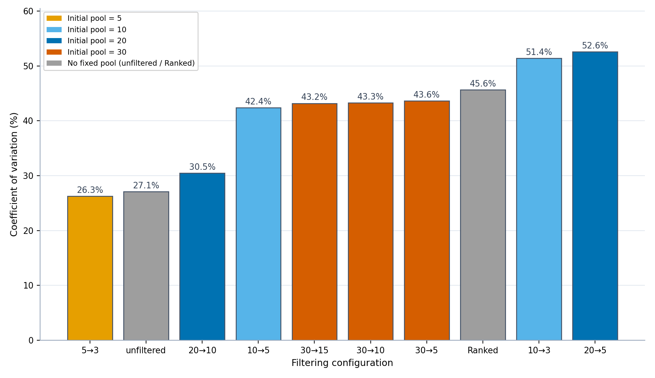

Figure 6 - GPT-5.1 coefficient of variation (CV) for every filtering configuration, colored by initial Stage-One pool size; lower values indicate more stable returns. Takeaway: returns are steadiest at the extremes — the most selective configuration (5→3) and the unfiltered baseline — and moderately more variable for the highest-returning configurations.
Filtering also shaped return consistency, though not monotonically: returns were steadiest at both extremes of filtering and more variable between. Figure 6 reports each configuration's coefficient of variation (CV); lower CV means tighter clustering around the mean.
For GPT-5.1, the most consistent configurations were the highly selective 5→3 (CV 26.3%) and the unfiltered baseline (27.1%), with 20→10 close behind (30.5%). The highest-returning configurations—10→5, 20→5, and 10→3—were moderately less consistent (CV 42–53%). In short, a little more return came with a little more variability.
This consistency ordering is governed by the same settings rather than being incidental. Run-to-run variability is lowest when the second stage is most decisive relative to its input — when the pool is small enough that the final choice is nearly forced (5→3) or when no filtering is imposed at all (the unfiltered baseline) — and highest for the mid-ratio configurations that carry more borderline candidates into the final portfolio. Because stability and return are shaped by the same initial-pool-and-ratio interaction, the return-maximizing 20→10 ranks just below the most stable configurations rather than among the most variable, which is what makes it a sensible default.
A note on interpretation: the configuration shapes the average level of return, not the outcome of any single run. Within a given configuration, individual runs vary more than the configurations’ means differ from one another, because most of the run-to-run variation traces to the evaluation window — the prevailing market regime — and to the model’s stochastic re-selection of stocks on each run, rather than to the configuration itself. The configuration effect is therefore assessed through averaged ROI and matched window-by-window win rates, which hold the market regime fixed and let the systematic difference emerge, rather than through the spread of individual runs.
Consistency was therefore not strictly monotonic in filtering strength for GPT-5.1: the single most selective configuration was the most stable, but the highest-returning configurations accepted moderately higher variance in exchange for their return advantage. These findings indicate that filtering shapes not only the level of GPT-5.1's returns but also their distribution, allowing practitioners to trade a portion of return for more consistent, predictable outcomes.

Model Comparison and Configuration Selection
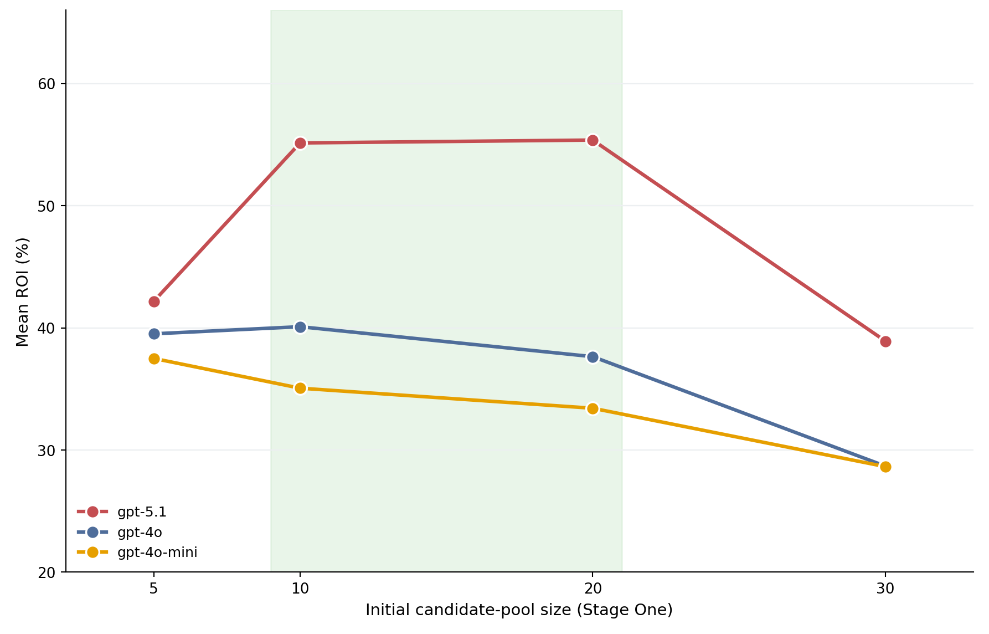

Figure 7 - Mean ROI by initial candidate-pool size for each model. GPT-5.1 leads at every pool size and peaks at a moderate pool of 10–20 candidates; GPT-4o peaks at ten, and GPT-4o-mini is highest at five. All three models decline for oversized 30-candidate pools.
Two factors determine which configuration to deploy: the underlying model, and how the desired portfolio size maps onto the two stages. Figure 7 compares the three models across fixed-pool configurations, while Table 1 and the matched win rates of Figure 4 identify the best configuration per target portfolio size; the unfiltered single-pass run is the baseline throughout.
Figure 7 plots mean ROI against initial candidate-pool size for each of the three models. GPT-5.1 (red) produced the highest ROI at every pool size, averaging 47.0% mean ROI across configurations versus 35.0% for GPT-4o and 32.7% for GPT-4o-mini, a gap of roughly 12 to 14 percentage points that holds across pool sizes. The shape of the curve, however, differs by model: GPT-5.1 traces a pronounced inverted-U peaking at 10–20 candidates; GPT-4o peaks modestly at ten, with its five-candidate pool outperforming its twenty; and GPT-4o-mini declines monotonically from a five-candidate maximum. What all three models share is the penalty for oversized pools — every model deteriorates at thirty candidates. This pattern suggests that the optimal pool size scales with model capability: a stronger model can fill a larger candidate request with conviction, while weaker models do best when asked for only as many names as they can justify. Raw model capability sets the overall return level, and the pipeline configuration determines how much of that level is realized.
The same data indicate how the best configuration shifts with the desired portfolio size (Table 1). For a concentrated three-stock portfolio, 10→3 is best (54.1%), beating the unfiltered baseline in 74.1% of matched windows and outperforming the more selective 5→3 (42.2%). For a five-stock portfolio, 10→5 leads (56.2%, beating the baseline 77.8% of the time), ahead of 20→5 (50.4%, 74.1%). For a ten-stock portfolio, 20→10 is both the best option and the single highest-returning configuration in the study (60.6%), beating the baseline in 81.5% of matched windows. A consistent pattern emerges: the best Stage One pool is roughly twice the target portfolio size (the 2× rule). The over-filtered methods identified in Figure 3 are dominated at every portfolio size and are not recommended.
The reason this pattern holds is the same factor identified in the baseline comparison: a Stage One pool of about twice the target size gives the model enough candidates to rank without overwhelming the validation stage. The desired number of holdings thus selects which moderate configuration to use, but it is the moderate regime itself — a mid-sized pool gently narrowed — that produces the return advantage, not the specific label.

Sector Allocation and Realized Returns
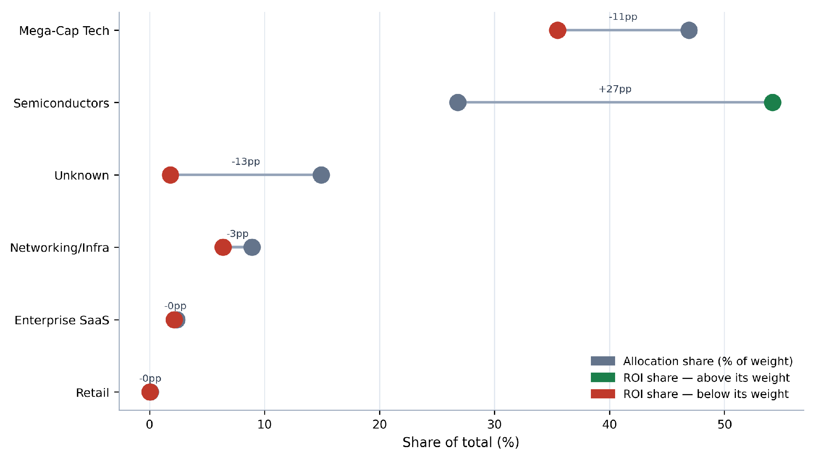

Figure 8 - GPT-5.1 sector allocation versus realized ROI share. For each sector, the left marker is its share of recommended portfolio weight and the right marker its share of total realized ROI.
Beyond aggregate returns, the sector composition of GPT-5.1's portfolios shows where its performance originated. Figure 8 compares each sector's share of the recommended portfolio weight with its share of the realized return. GPT-5.1 allocated the largest share of capital to Mega-Cap Technology (46.9% of weight), yet that sector delivered only 35.5% of realized ROI; Semiconductors, at 26.8% of weight, contributed 54.2% of the realized return — roughly twice their allocation — making them the dominant source of performance. Networking/Infrastructure (8.9% of weight, 6.4% of ROI) and Enterprise SaaS (2.4%, 2.1%) contributed broadly in line with their weights, while a 14.9% allocation to unclassified holdings produced just 1.8% of the realized return. These results indicate that the framework's returns were driven disproportionately by semiconductor selections, and that allocation share alone understates where performance actually originated.

Discussion

Implications and Significance
The results point to a single, transferable lesson: how the information given to a language model is structured is itself a determinant of investment performance, separate from the choice of model. Presenting the model with a moderate shortlist and asking it to narrow that shortlist — rather than letting it select from an unstructured prompt or forcing it to discard most of an oversized pool — consistently produced the strongest and most reliable returns. Because this gain comes from the design of the pipeline rather than from a larger or newer model, it is available to any practitioner at essentially no additional cost.
The mechanism behind the effect is the size of the first-stage candidate pool. For GPT-5.1, returns rise and then fall as that pool grows: too few candidates leave the model with too little to choose from, while too many force it to nominate companies beyond those it can justify, filling the candidate list with weak selections that remain in the final portfolio. The practical guideline that follows is simple for frontier-class models — begin from a pool of roughly ten to twenty candidates and narrow it by about two to one; the weaker models tested peaked at smaller pools, suggesting that the optimal request scales with model capability. The reduction ratio matters mainly through how aggressively it cuts a given pool, and the final portfolio size can then be chosen to match an investor's diversification preference without sacrificing the structural advantage.
These findings also clarify what the framework does and does not establish. Because the unfiltered baseline already beat the market benchmark, the contribution specific to the two-stage design is its consistent improvement over that baseline under matched conditions, not the market outperformance itself. More broadly, the study suggests that for LLM-driven decision systems, deliberate information design is an inexpensive and model-agnostic complement to advances in model scale.

Limitations and Future Work
Several limitations bound the scope of these findings. All portfolios are long-only and buy-and-hold, and returns are computed without transaction costs, taxes, or slippage, which would modestly reduce realized performance. The investment universe is restricted to a fixed set of large-capitalization technology and semiconductor equities, so the sector-contribution results in particular may not generalize to broader markets. Because GPT-5.1's evaluation windows are constrained to begin after its training cutoff, its results rest on fewer rolling windows (October 2024 onward) than the older models, and all windows fall within a broadly rising market; performance in a sustained downturn is therefore untested. Finally, the analysis reports raw and benchmark-relative returns together with the coefficient of variation, but does not compute risk-adjusted measures such as the Sharpe or Sortino ratio or maximum drawdown, because the per-portfolio daily return series required for them were not retained.
Future work should address these gaps directly: incorporating transaction-cost and drawdown modeling, extending the universe beyond technology to test sector generalization, evaluating across bear-market windows as longer post-cutoff histories become available, and adding risk-adjusted performance metrics. Live forward-testing — deploying the recommended configuration prospectively rather than on historical windows — would provide the strongest evidence that the framework's advantage over the unfiltered single-pass methodology persists out of sample.

Conclusion
This study set out to test whether structuring the information given to a language model could improve long-term stock selection. Across 2,759 portfolio runs, a two-stage pipeline — using news to assemble a candidate shortlist and financial reports to validate it — reliably outperformed both unfiltered single-pass prompting and aggressive over-filtering. The largest gains came from a moderate design: starting from about ten to twenty candidates and narrowing them by roughly half (the 2× rule) added on the order of fifteen percentage points of mean ROI over the unfiltered baseline and beat it in most matched evaluation windows. The central takeaway is that information design is a distinct and inexpensive determinant of performance in LLM-based investing, comparable in importance to the choice of model. Subject to the limitations above, this points toward a broader direction for LLM agents: treating the structure of a model's inputs as a first-class design variable rather than an afterthought.

References
1. S. An, Q. Li, J. Lu, D. Yin, X. Sun. FinVerse: an autonomous agent system for versatile financial analysis. arXiv, 2024, https://doi.org/10.48550/arXiv.2406.06379.
2. K. Anjum, M. A. Arshad, K. Hayawi, E. Polyzos, A. Tariq, M. A. Serhani, L. Batool, B. Lund, N. R. Mannuru, R. V. K. Bevara, T. Mahbub, M. Z. Akram, S. Shahriar. Domain specific benchmarks for evaluating multimodal large language models. arXiv, 2025, https://doi.org/10.48550/arXiv.2506.12958.
3. A. Lopez-Lira, Y. Tang. Can ChatGPT forecast stock price movements? return predictability and large language models. SSRN. 2023, https://doi.org/10.2139/ssrn.4412788.
4. Y. Xiao, E. Sun, D. Luo, W. Wang. TradingAgents: multi-agents LLM financial trading framework. arXiv, 2024, https://doi.org/10.48550/arXiv.2412.20138.
5. D. Blitz, M. X. Hanauer, T. Hoogteijling, C. Howard. The term structure of machine learning alpha. The Journal of Financial Data Science. Vol. 5, pg. 40–58, 2023, https://doi.org/10.2139/ssrn.4474637.
6. W. W. Li, H. Kim, M. Cucuringu, T. Ma. Can LLM-based financial investing strategies outperform the market in the long run? arXiv, 2025, https://doi.org/10.48550/arXiv.2505.07078.
7. B. Cao, S. Wang, X. Lin, X. Wu, H. Zhang, L. M. Ni, J. Guo. From deep learning to LLMs: a survey of AI in quantitative investment. arXiv, 2025, https://doi.org/10.48550/arXiv.2503.21422.
8. J. Cheng, P. Chin. AAPM: large language model agent-based asset pricing models. arXiv, 2024, https://doi.org/10.48550/arXiv.2409.17266.
9. G. Lu, S. B. Larcher, T. Tran. Hybrid long document summarization using C2F-FAR and ChatGPT: a practical study. arXiv, 2023, https://doi.org/10.48550/arXiv.2306.01169.
10. C. Choi, A. Lopez-Lira, Y. Lee, J. Kwon, M. Kim, J. Hwang, M. Ha, C. Kim, J. Ha, S. Yun, J. Kim. Structuring the unstructured: a multi-agent system for extracting and querying financial KPIs and guidance. arXiv, 2025, https://doi.org/10.48550/arXiv.2505.19197.
11. H. Ding, Y. Li, J. Wang, H. Chen. Large language model agent in financial trading: a survey. arXiv, 2024, https://doi.org/10.48550/arXiv.2408.06361.
12. S. Fatemi, Y. Hu. Enhancing financial question answering with a multi-agent reflection framework. Proceedings of the 5th ACM International Conference on AI in Finance. 2024.
13. G. Fatouros, K. Metaxas, J. Soldatos, M. Karathanassis. MarketSenseAI 2.0: enhancing stock analysis through LLM agents. arXiv, 2025, https://doi.org/10.48550/arXiv.2502.00415.
14. B. Fazlija, M. Ibraimi, A. Forouzandeh, A. Fazlija. Implementing financial regulations using large language models. SSRN. 2024, https://doi.org/10.2139/ssrn.5010694.
15. T. Guo, H. Shen, J. Huang, Z. Mao, J. Luo, B. Chen, Z. Chen, L. Liu, B. Xia, X. Liu, Y. Ma, M. Zhang. MASS: multi-agent simulation scaling for portfolio construction. arXiv, 2025, https://doi.org/10.48550/arXiv.2505.10278.
16. T. Guo, X. Chen, Y. Wang, R. Chang, S. Pei, N. V. Chawla, O. Wiest, X. Zhang. Large language model based multi-agents: a survey of progress and challenges. arXiv, 2024, https://doi.org/10.48550/arXiv.2402.01680.
17. X. Han, N. Wang, S. Che, H. Yang, K. Zhang, S. X. Xu. Enhancing investment analysis: optimizing AI-agent collaboration in financial research. Proceedings of the 5th ACM International Conference on AI in Finance. 2024, https://doi.org/10.48550/arXiv.2411.04788.
18. S. Joshi. A comprehensive review of gen AI agents: applications and frameworks in finance, investments and risk domains. International Journal of Innovative Science and Research Technology. 2025.
19. J. Luo, W. Zhang, Y. Yuan, Y. Zhao, J. Yang, Y. Gu, B. Wu, B. Chen, Z. Qiao, Q. Long, R. Tu, X. Luo, W. Ju, Z. Xiao, Y. Wang, M. Xiao, C. Liu, J. Yuan, S. Zhang, Y. Jin, F. Zhang, X. Wu, H. Zhao, D. Tao, P. S. Yu, M. Zhang. Large language model agent: a survey on methodology, applications and challenges. arXiv, 2025, https://doi.org/10.48550/arXiv.2503.21460.
20. S. Joshi. A literature review of gen AI agents in financial applications: models and implementations. SSRN. 2025, https://doi.org/10.2139/ssrn.5133985.
21. Z. Kou, H. Yu, J. Luo, J. Peng, X. Li, C. Liu, J. Dai, L. Chen, S. Han, Y. Guo. Automate strategy finding with LLM in quantitative investment. arXiv, 2024, https://doi.org/10.48550/arXiv.2409.06289.
22. J. Lee, N. Stevens, S. C. Han, M. Song. A survey of large language models in finance (FinLLMs). Neural Computing and Applications. Vol. 37, pg. 24853–24867, 2024, https://doi.org/10.48550/arXiv.2402.02315.
23. H. Li, Y. Cao, Y. Yu, S. R. Javaji, Z. Deng, Y. He, Y. Jiang, Z. Zhu, K. Subbalakshmi, G. Xiong, J. Huang, L. Qian, X. Peng, Q. Xie, J. W. Suchow. InvestorBench: a benchmark for financial decision-making tasks with LLM-based agents. arXiv, 2024, https://doi.org/10.48550/arXiv.2412.18174.
24. J. Li, J. Zhang, H. Li, Y. Shen. An agent framework for real-time financial information searching with large language models. arXiv, 2025, https://doi.org/10.48550/arXiv.2502.15684.
25. K. Chen, H. Ahmad, D. Goel, C. Szabo. 3S-trader: a multi-LLM framework for adaptive stock scoring, strategy, and selection in portfolio optimization. arXiv, 2025, https://doi.org/10.48550/arXiv.2510.17393.
26. T. Zhao, J. Lyu, S. Jones, H. Garber, S. Pasquali, D. Mehta. AlphaAgents: large language model-based multi-agents for equity portfolio constructions. arXiv, 2025, https://doi.org/10.48550/arXiv.2508.11152.
27. T. Zhou, P. Wang, Y. Wu, H. Yang. FinRobot: AI agent for equity research and valuation with large language models. arXiv, 2024, https://doi.org/10.48550/arXiv.2411.08804.
28. W. Zhang, L. Zhao, H. Xia, S. Sun, J. Sun, M. Qin, X. Li, Y. Zhao, Y. Zhao, X. Cai, L. Zheng, X. Wang, B. An. A multimodal foundation agent for financial trading: tool-augmented, diversified, and generalist. Proceedings of the 30th ACM SIGKDD Conference on Knowledge Discovery and Data Mining. 2024, https://doi.org/10.48550/arXiv.2402.18485.
29. N. Li, C. Gao, M. Li, Y. Li, Q. Liao. EconAgent: large language model-empowered agents for simulating macroeconomic activities. arXiv, 2023, https://doi.org/10.48550/arXiv.2310.10436.
30. Y. Li, Y. Yu, H. Li, Z. Chen, K. Khashanah. TradingGPT: multi-agent system with layered memory and distinct characters for enhanced financial trading performance. arXiv, 2023, https://doi.org/10.48550/arXiv.2309.03736.
31. A. Lopez-Lira. Can large language models trade? testing financial theories with LLM agents in market simulations. arXiv, 2025, https://doi.org/10.48550/arXiv.2504.10789.
32. I. Mirzadeh, K. Alizadeh, H. Shahrokhi, O. Tuzel, S. Bengio, M. Farajtabar. GSM-symbolic: understanding the limitations of mathematical reasoning in large language models. International Conference on Learning Representations (ICLR 2025). 2025, https://doi.org/10.48550/arXiv.2410.05229.
33. H. Naveed, A. U. Khan, S. Qiu, M. Saqib, S. Anwar, M. Usman, N. Akhtar, N. Barnes, A. Mian. A comprehensive overview of large language models. ACM Transactions on Intelligent Systems and Technology. 2023, https://doi.org/10.48550/arXiv.2307.06435.
34. Y. Nie, Y. Kong, X. Dong, J. M. Mulvey, H. V. Poor, Q. Wen, S. Zohren. A survey of large language models for financial applications: progress, prospects and challenges. arXiv, 2024, https://doi.org/10.48550/arXiv.2406.11903.
35. I. Okpala, A. Golgoon, A. R. Kannan. Agentic AI systems applied to tasks in financial services: modeling and model risk management crews. arXiv, 2025, https://doi.org/10.48550/arXiv.2502.05439.
36. R. Sapkota, K. I. Roumeliotis, M. Karkee. AI agents vs. agentic AI: a conceptual taxonomy, applications, and challenges. arXiv, 2025, https://doi.org/10.48550/arXiv.2505.10468.
37. T. Takayanagi, K. Izumi, J. Sanz-Cruzado, R. McCreadie, I. Ounis. Are generative AI agents effective personalized financial advisors? arXiv, 2025, https://doi.org/10.48550/arXiv.2504.05862.
38. T. Takayanagi, M. Suzuki, K. Izumi, J. Sanz-Cruzado, R. McCreadie, I. Ounis. FinPersona: an LLM-driven conversational agent for personalized financial advising. Advances in Information Retrieval (ECIR 2025), Lecture Notes in Computer Science. Vol. 15576, pg. 13–18, 2025, https://doi.org/10.1007/978-3-031-88720-8_3.
39. P. C. Tetlock. Giving content to investor sentiment: the role of media in the stock market. The Journal of Finance. Vol. 62, pg. 1139–1168, 2007, https://doi.org/10.1111/j.1540-6261.2007.01232.x.
40. A. Vidler, T. Walsh. Shifting power: leveraging LLMs to simulate human aversion in ABMs of bilateral financial exchanges. arXiv, 2025, https://doi.org/10.48550/arXiv.2503.00320.
41. S. Wang, H. Yuan, L. M. Ni, J. Guo. QuantAgent: seeking the holy grail in trading by self-improving large language models. arXiv, 2024, https://doi.org/10.48550/arXiv.2402.03755.
42. Y. Yu, H. Li, Z. Chen, Y. Jiang, Y. Li, D. Zhang, R. Liu, J. W. Suchow, K. Khashanah. FinMem: a performance-enhanced LLM trading agent with layered memory and character design. AAAI Symposium Series. 2024, https://doi.org/10.48550/arXiv.2311.13743.
43. H. Yuan, S. Wang, J. Guo. Alpha-GPT 2.0: human-in-the-loop AI for quantitative investment. arXiv, 2024, https://doi.org/10.48550/arXiv.2402.09746.
44. C. Zhang, X. Liu, M. Jin, Z. Zhang, L. Li, Z. Wang, W. Hua, D. Shu, S. Zhu, X. Jin, S. Li, M. Du, Y. Zhang. When AI meets finance (StockAgent): large language model-based stock trading in simulated real-world environments. arXiv, 2024, https://doi.org/10.48550/arXiv.2407.18957.
45. Y. Zhang, Y. Li, L. Cui, D. Cai, L. Liu, T. Fu, X. Huang, E. Zhao, Y. Zhang, C. Xu, Y. Chen, L. Wang, A. T. Luu, W. Bi, F. Shi, S. Shi. Siren's song in the AI ocean: a survey on hallucination in large language models. Computational Linguistics. 2025, https://doi.org/10.48550/arXiv.2309.01219.

